CLOUD COMPUTING LAB – A4

***K GANESH VAIDYANATHAN***

***SECTION – E***

***PES1UG21CS253***

Screenshot of the running Docker Container after installing Jenkins

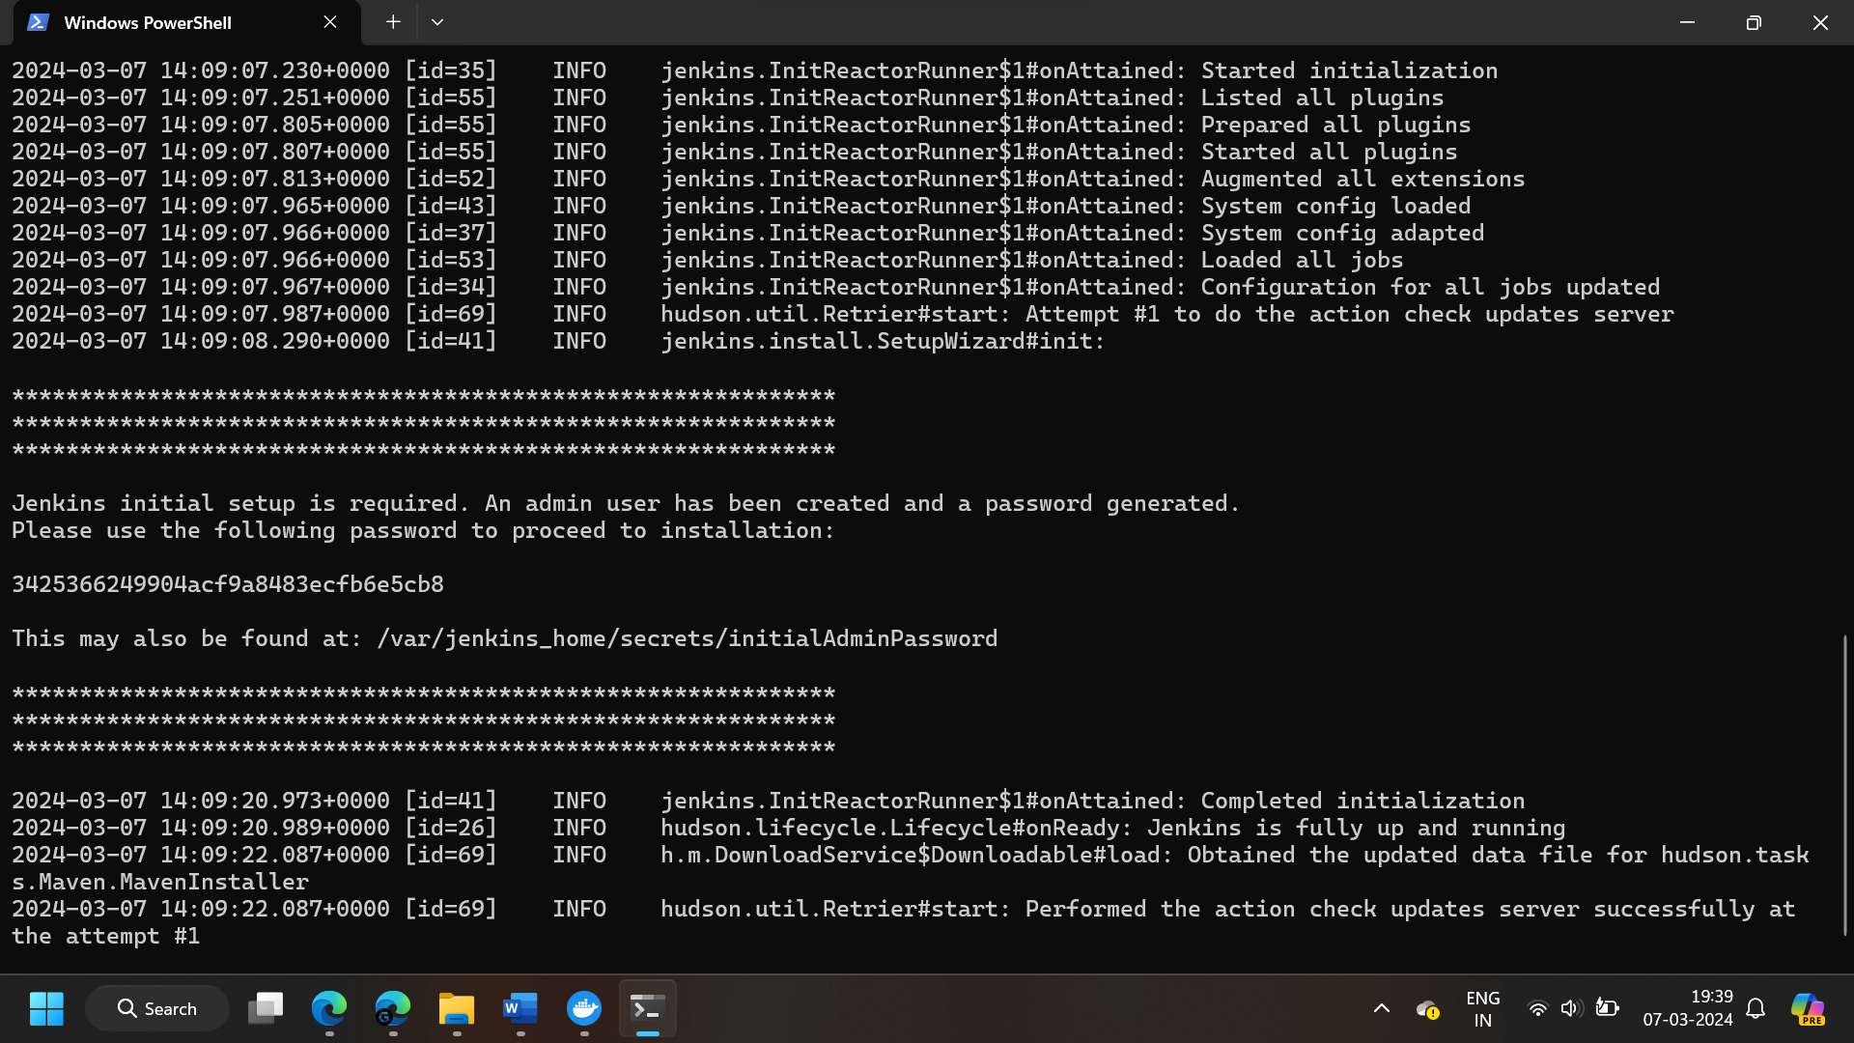

3425366249904acf9a8483ecfb6e5cb8

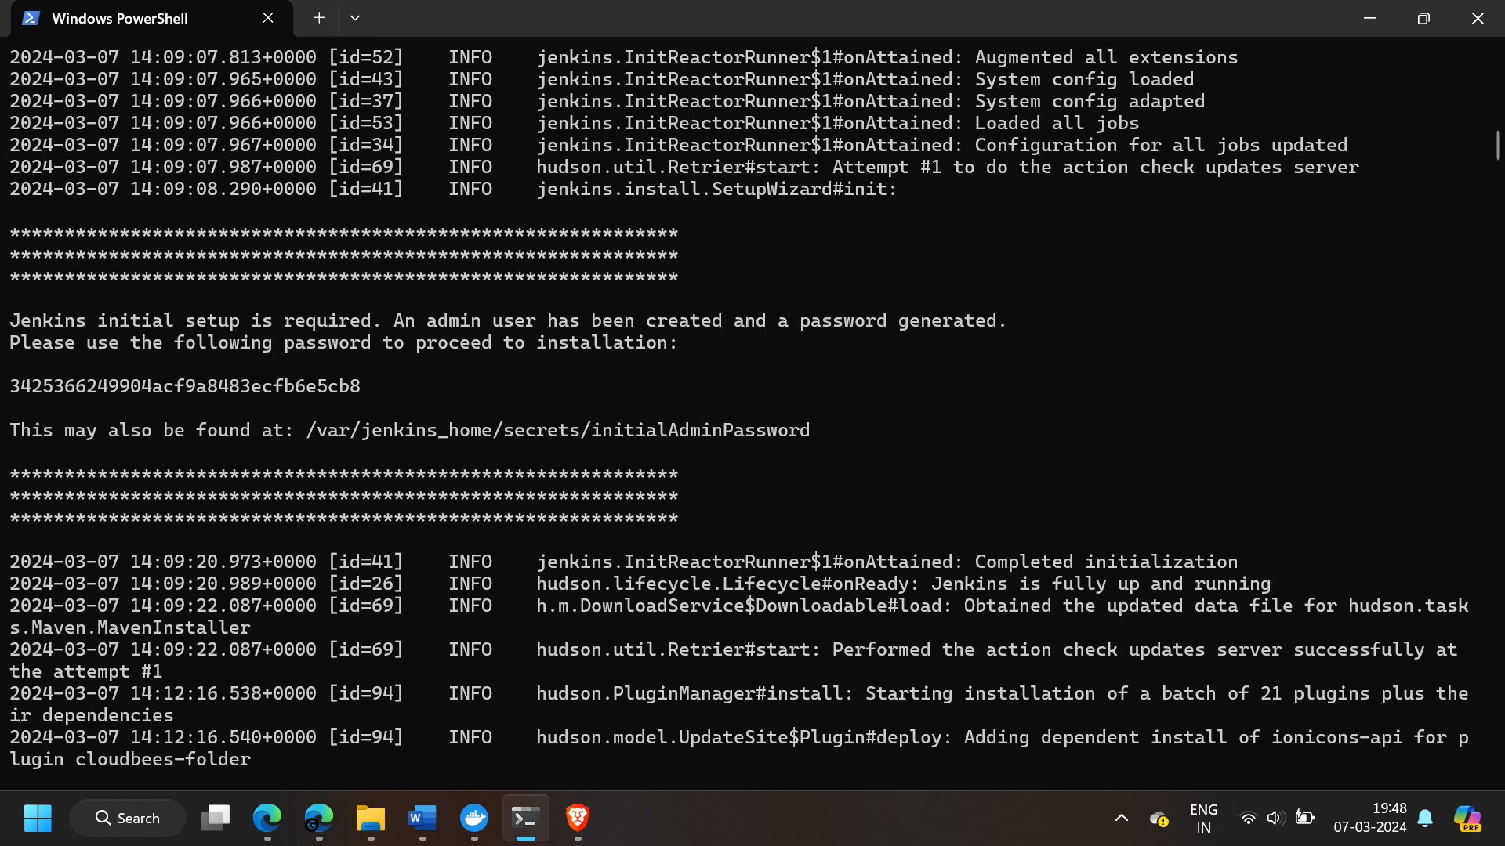

a69582cf87f34a4f848f650c107a9340

